Instruction
- Look for electrical devices e.g. in the classroom, in the staff room, in the school building, in your school bag (yes, mobile phone!) and look at the hair dryer you brought with you. Find the label where the electrical energy consumption is written
- Write it in the list/worksheet (below), and take a photo of the electrical appliance or draw it and document its energy consumption.
- Calculate the energy-consumption of all devices, if you use them for 1 minute, 1 hour , 1 day, 1 year Use the list below.
- Mind: There are many electrical devices that you use either longer or shorter than 1 hour. For example, the refrigerator also consumes electricity, or energy. You probably know that the refrigerator is always on to keep certain foods fresh. You don't turn a refrigerator on and off, as you do with a toaster, for example. And a toaster doesn't toast your bread for a whole hour, because otherwise it would be completely burnt…

Worksheet 1: List of electric devices you found - continue!

Device - picture/drawing | Device - eclectic power
 | 2000 W
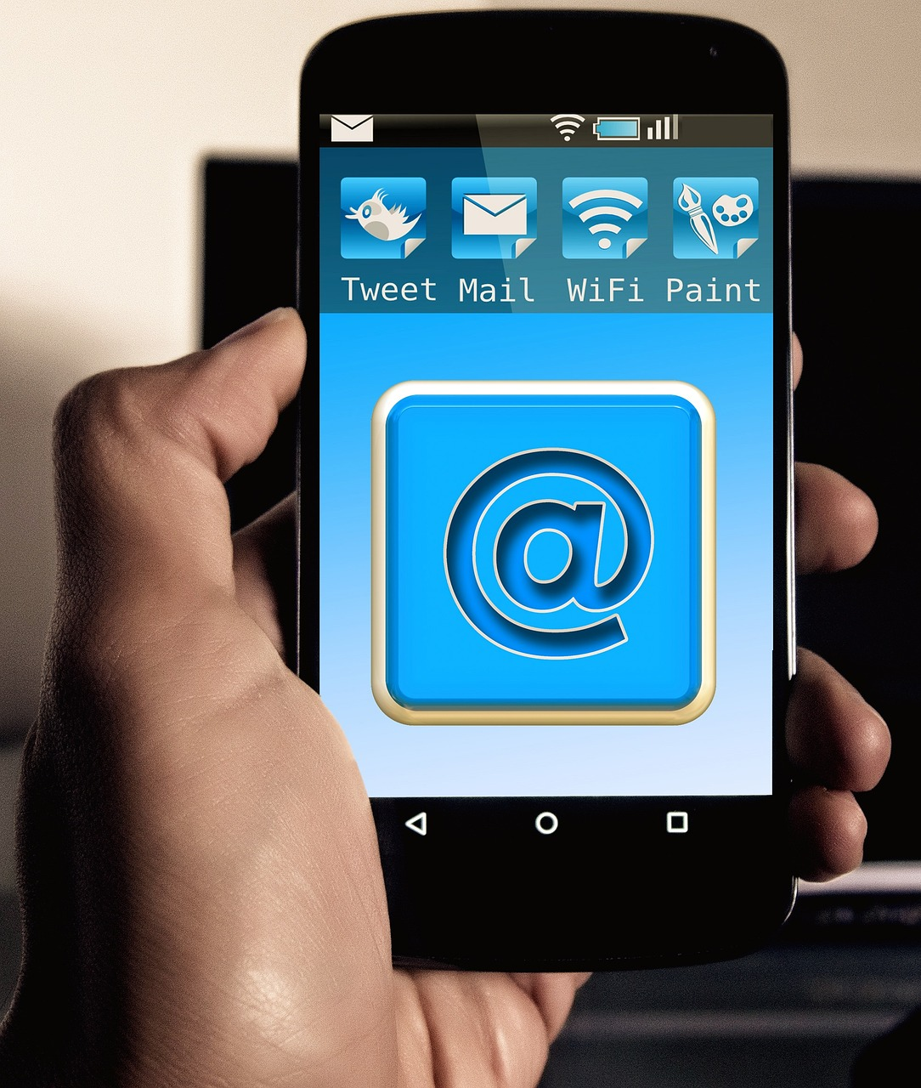 | 20 W

Worksheet 2: Your own observations - physical quantities

Electrical device | power | Time  1 minute | Time  1 hour | Time 1 day | Time 1 year | Conversion to kilowatt-hours
vacuum cleaner | 1,600 watt | 27 watt/min. | 1600 watt/h |  |  | = 1.6 kw/h
Washing-machine | 2,000 watts | 33 watt/min. | 2000 watt/h |  |  | = 2 kw/h
Oven | 3,000 watts | 50 watt/min. | 3000 watt/h |  |  | = 3 kw/h
electric hair-dryer | 2.000 watts | 33 watt/min | 2000 watt/h
mobile phone | 20 watts | 0,3 watt/min. | 20 watt/h
refrigerator

Deepening
- Calculate the Carbon-Dioxid-Emissions per day/per Year of the electrical devices you found!
- Compare: Carbon-Dioxid-Emissions per day/per Year of electrical devices in different countries! This differs according to the amount of renewable energies which a countries uses to produce electricity! Use the map below (Carbon intensity)
CO2 emissions per kilowatt hour of electricity in further decline in 2019 | Umweltbundesamt
Carbon intensity of electricity, 2022 (ourworldindata.org)
Reflection activity
- A mobile-phone can charge with 20 Wh → means: There is energy-content of 20 W after 1 Hour.
- A Fan runs with 2000 W
- Question: How long can you run your fan, to consume the energy of 1 load of your smart-phone?
- Answer:
  - 1 h = 2000 Wh → 1/2000 h = 1 Wh
  - → 20 Wh = 1/2000*20 h = 1/200 h
  - → 1/200h =36 sek!
Now you know why using a towel to dry your hair contributes to the fight against climate-change!

Action!
- Turn off the lights when you leave a room to save electricity.
- Check your home to see if you still have old light bulbs in the lamps. You can use them for light in the cellar, which is not turned on so often.
- Together with your parents, get LEDs instead of light bulbs for lamps in your home that are often switched on and off.
- Always close the fridge and freezer doors properly so that you only cool your food and not the whole flat. That would be quite a waste of energy ...
- Switch off all devices that you are not using at the moment. If a small red light is still on, it indicates that the appliance is only "sleeping", i.e. in stand-by mode, which also consumes electricity🡪 This means that you should also switch off the red button of the appliances completely. This is very often forgotten.
- Pre-dry your hair with a towel before blow-drying.
- In summer, you can even do without blow-drying altogether!
- Only heat as much water for tea water as you really need! For example, you can first fill your teacup with water and then put this water into the kettle, then heat exactly the right amount of water😊.
- Keep tea or hot drinks in the thermos flask, so the liquid stays warm.
- Research more energy-saving tips on the internet.

