Field&Sharing@venture
fast track

The field mission & celebration

Setting the Stage

Goal / Objectives
- The student will learn how to identify your strengths and your areas of positive impact
- The student will practice how to research, contact and interview sustainable initiatives
- The student will learn to document their experience, create a cool video or podcast, and share your story and creation with the peers, partner school and/or local media!

Participants | Duration | Materials/Location
Number: 3-99 (partially in groups of 2-5)  Age: 14+ | 230 min - fast track | Projector, smart-phones or PC/TV to play the Videos, access to the internet,  pen to fill out the worksheets, phone for the field mission call, software/app/equipment for video/podcast creation

Preparation
- Organize a projector to go through the presentation together, you need internet for the videos
- Printing out the worksheets/handout: YourStrength&positiveImpact.pdf
- Printing out the certificates for your students and fill in their names :)
- Tell your students that in this Module, their creativity can flow without any limits!

Step by step

Step | Slide | Time | Instructions
1. | Your Field Mission and Celebration  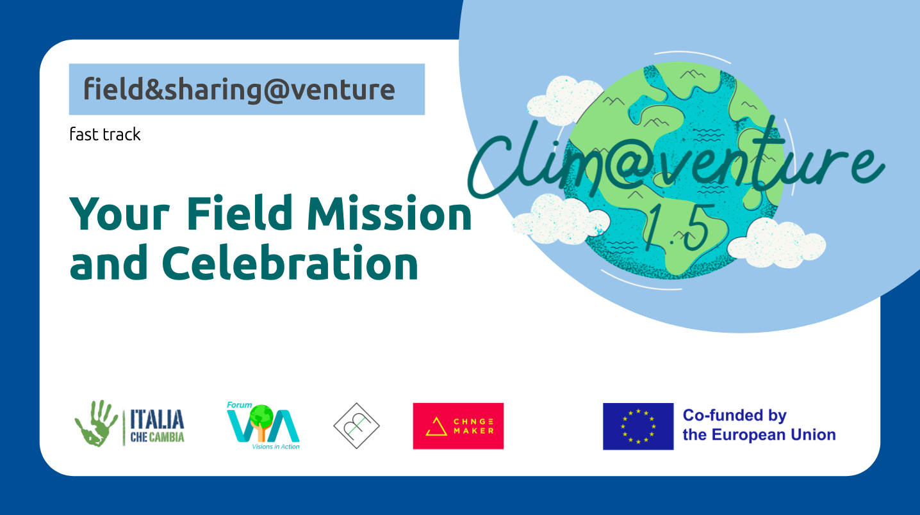 | 2´ | Tell your students to have come to the “grande finale” of the whole Clim@venture: now you can practice what you have learned in the previous module and reach out to inspiring people and initiatives of your choice!
2.  Optional | What SDG is speaking to you most?  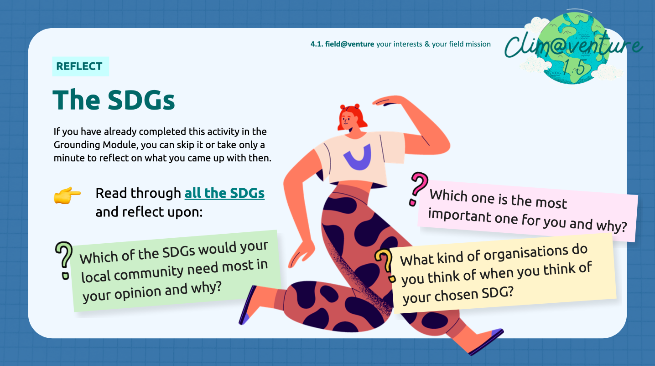 | 10’ | This slide and the following slide is optional. It is a deep dive into your student’s interests and areas of positive impact. Basically a reflection exercise to get to know oneself. This can be helpful to find out what kind of initiatives and projects the student wants to interview.  Click on this link: https://sdgs.un.org/goals and read through all SDGS and answer three questions  1) Which one is the most important one for you and why?  2) What kind of organisations do you think of when you think of your chosen SDG?  3) Which of the SDGs would your local community need most in your opinion and why?
3.  Optional | Your personal Strengths & Fields of Positive Impact  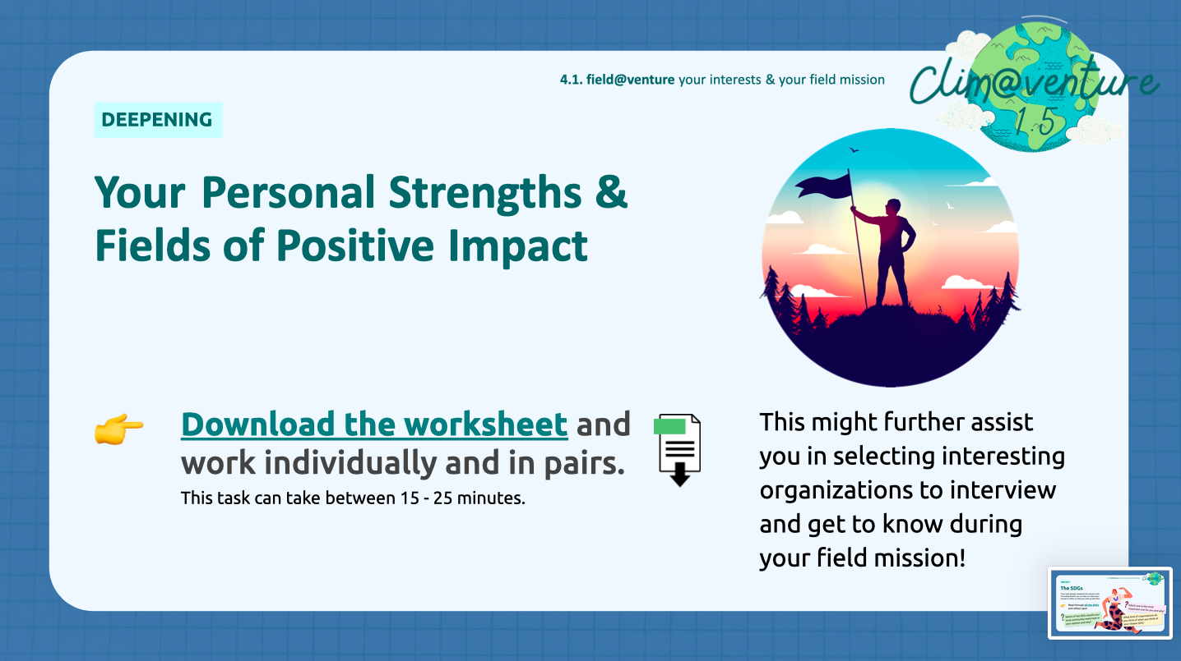 | 15’ | This is done individually and then in combination with a partner.  YourStrength&positiveImpact.pdf
4. | The Value of the field mission!  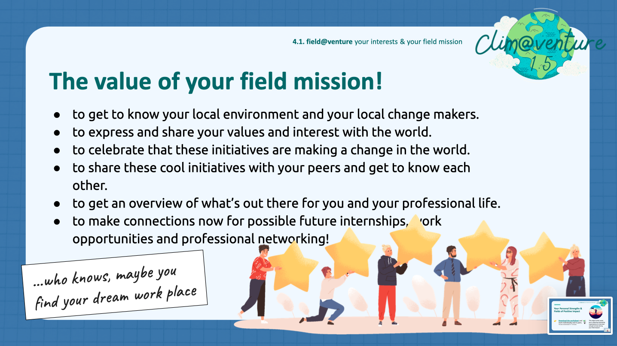 | 5’ | If students may be still wondering why they “have to” do this field mission, or you see that there is no motivation for this module, remind them about the value and the potential of this mission if they make it to their own journey!
5. | Contacts for your field mission  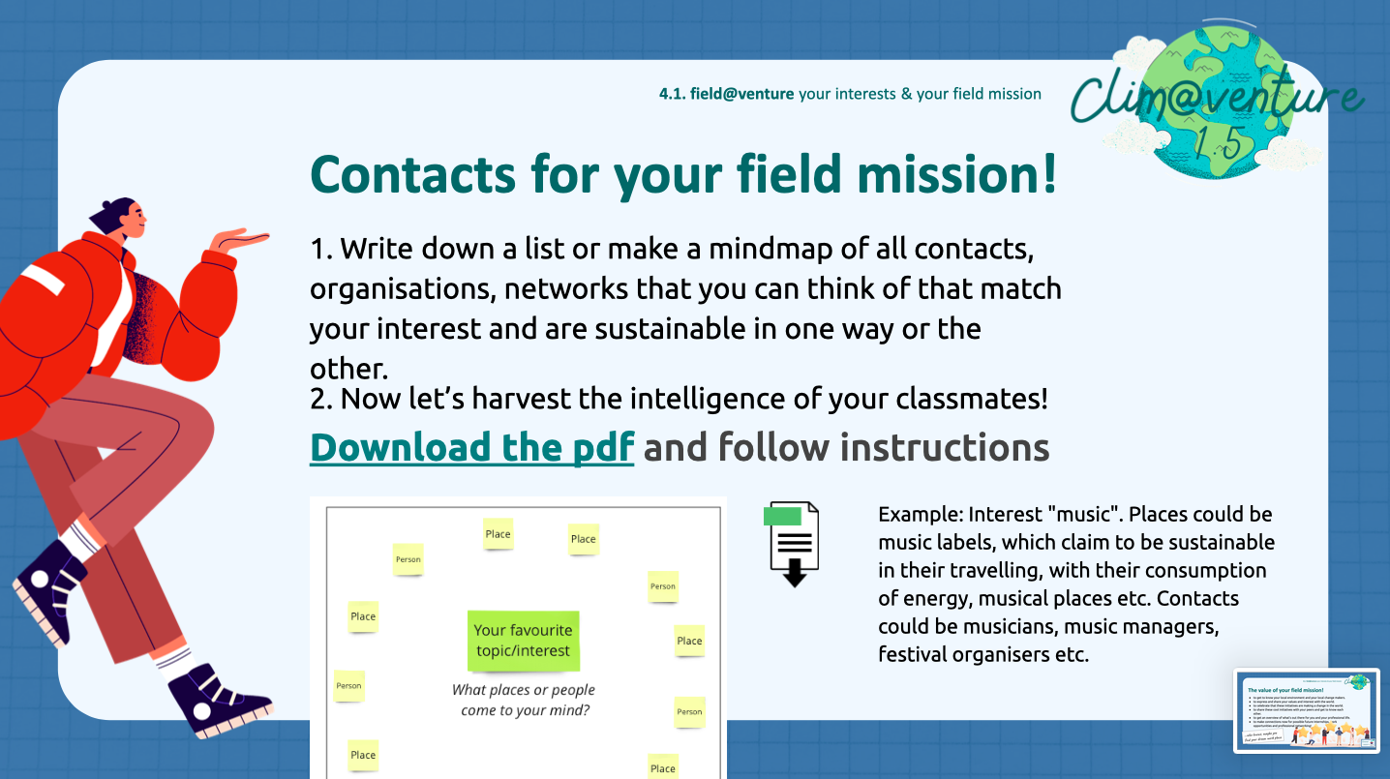 | 15’ | A simple but powerful way to gather contacts for each student’s field of interest. Other students might know a neighbor, friend or family member who is doing a cool thing connected to the student’s interest.  Ideally they will all end up with a paper with many different names of people, projects and organizations that they can now choose from to interview!
6.  Optional | Greenwashing?  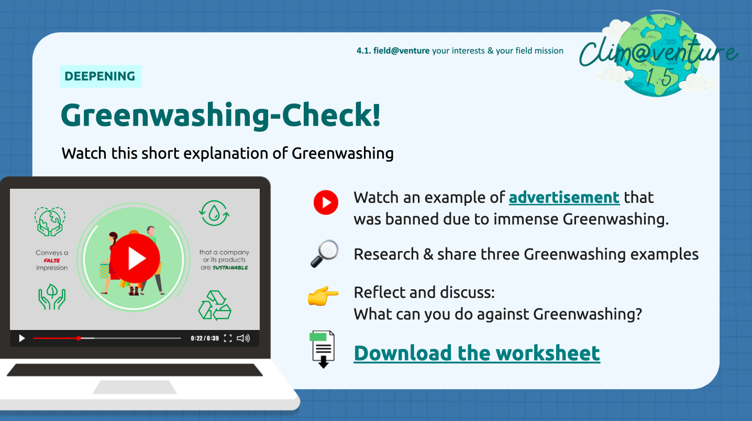 | 15’ | This is optional.  This is an activity to get an understanding about green washing and critical thinking about the students’ initiatives.
7.  Optional | How to reach out to the initiatives  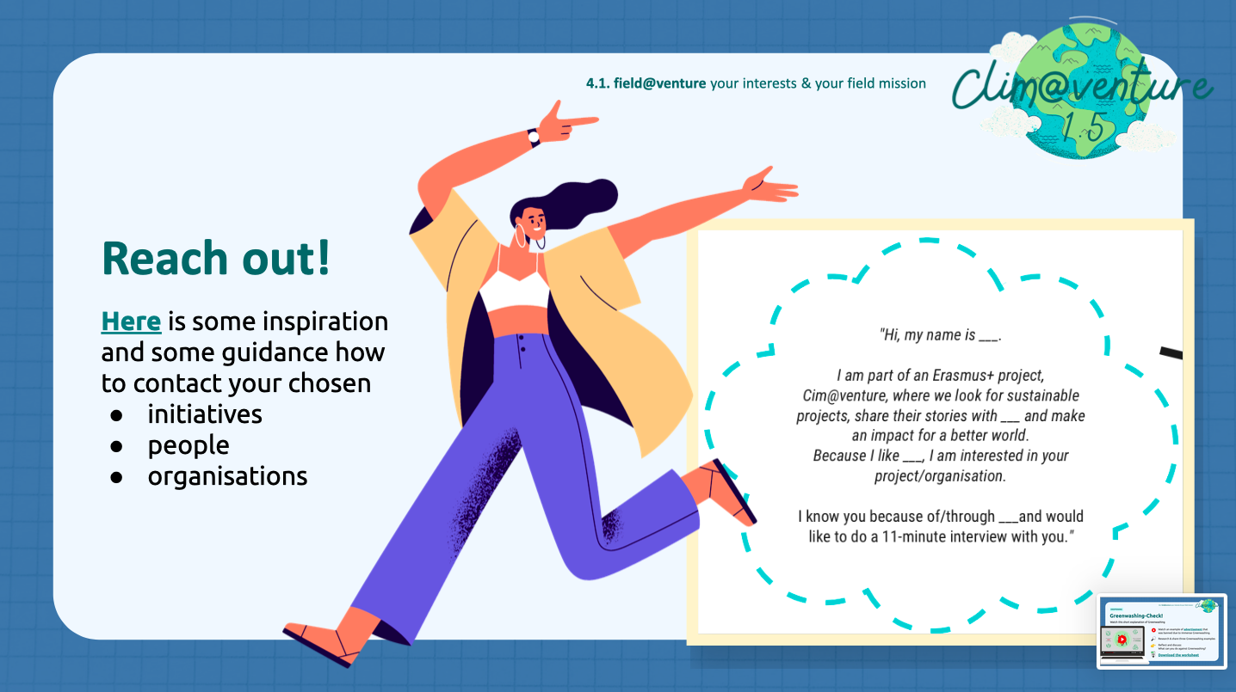 | 3’ | If some of your students might need a little help and inspiration on how to contact their chosen initiatives and organizations, this is a template to take!
8. | 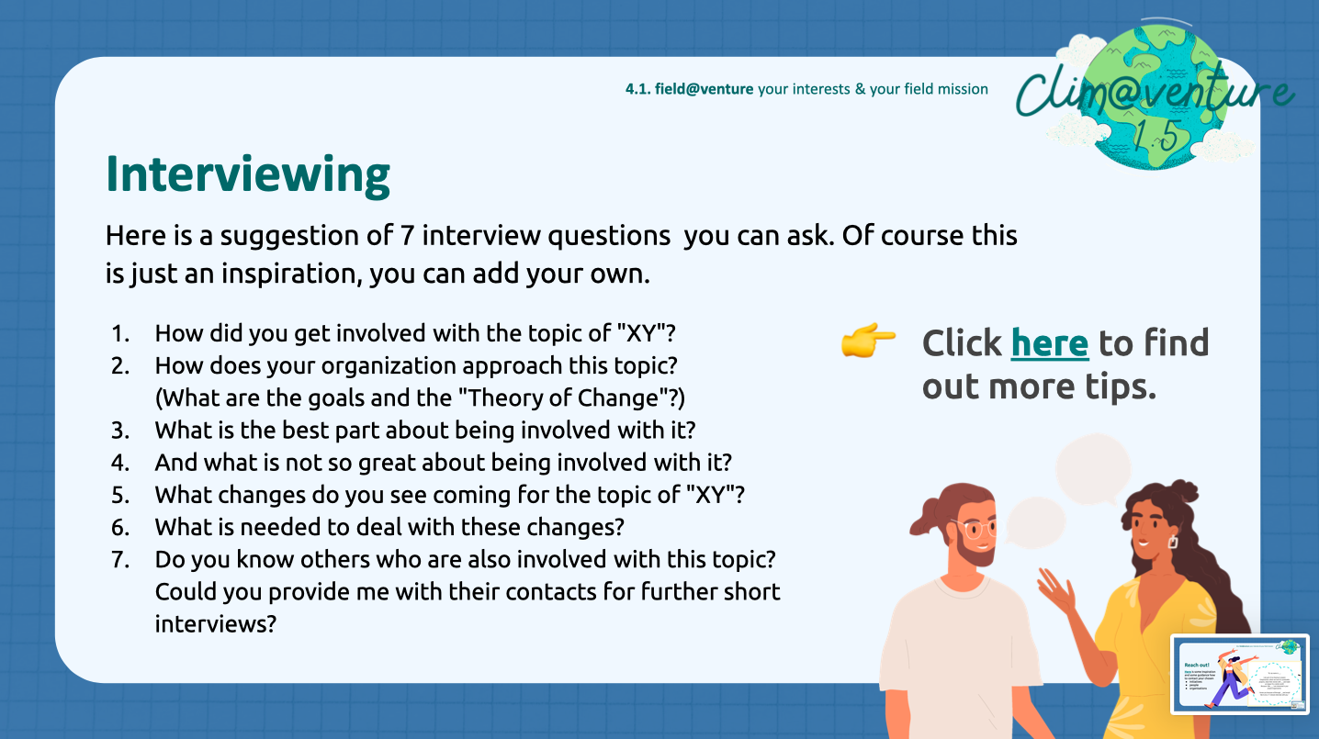 | 5’ | These are Interview questions that your students can ask. They can of course also make up their own.
9. | 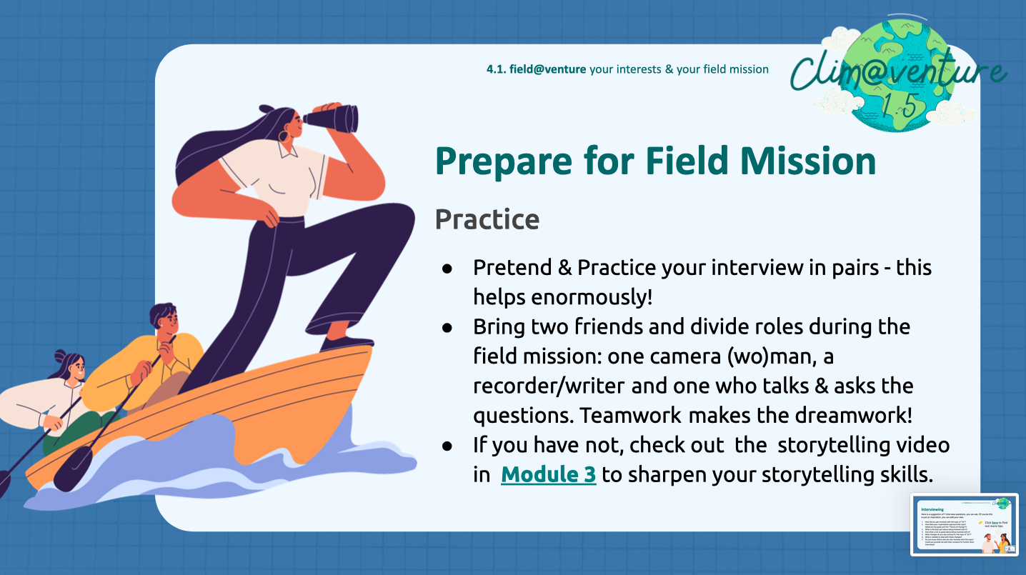 | 15’ | Explore together what can help enormously to make your students feel ready and confident.  Make your students practice the interview once or twice before the actual interview, with a classmate.  - Encourage them to bring two classmates and divide roles during the field mission: one camera (wo)man, a recorder/writer and one who talks & asks the questions. Teamwork makes the dreamwork!
10. | 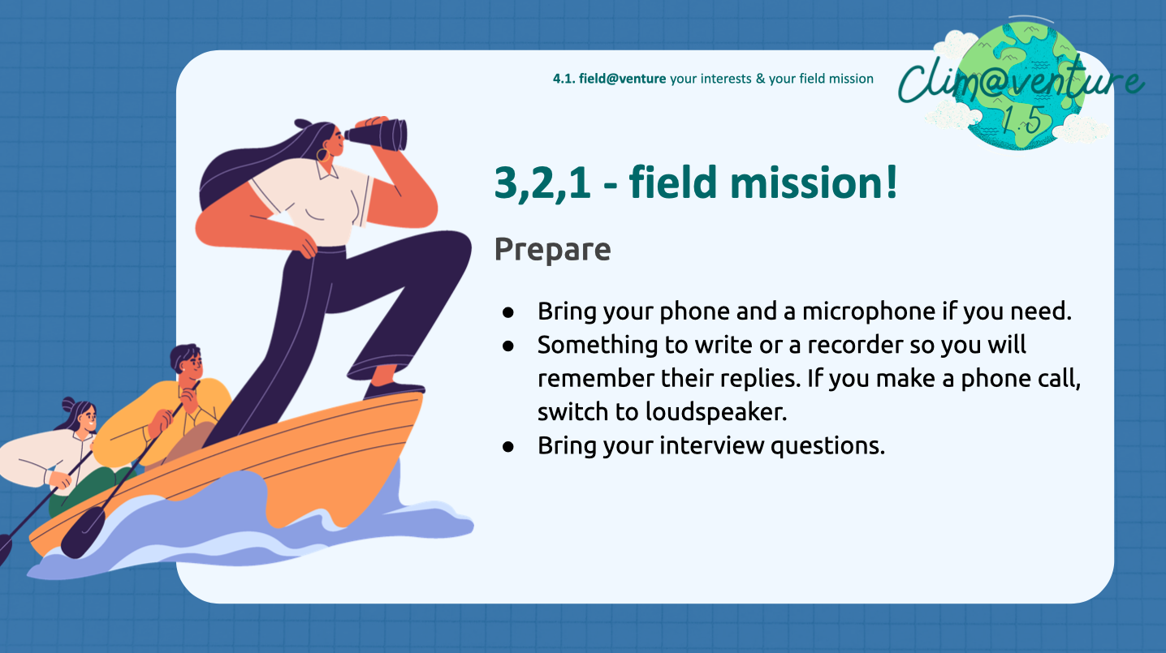 | 5’ | Remind your students to bring their phone and a microphone if they need.  Something to write or a recorder so they will remember the replies. If they make a phone call, they can switch to loudspeaker and take notes at the same time or have a classmate do it for them..  Remind them to bring their interview questions.  Also, you never know who you will interview and if they want to be filmed. If people do NOT want to be video recorded, your students can also create a podcast instead of a video!
11. | 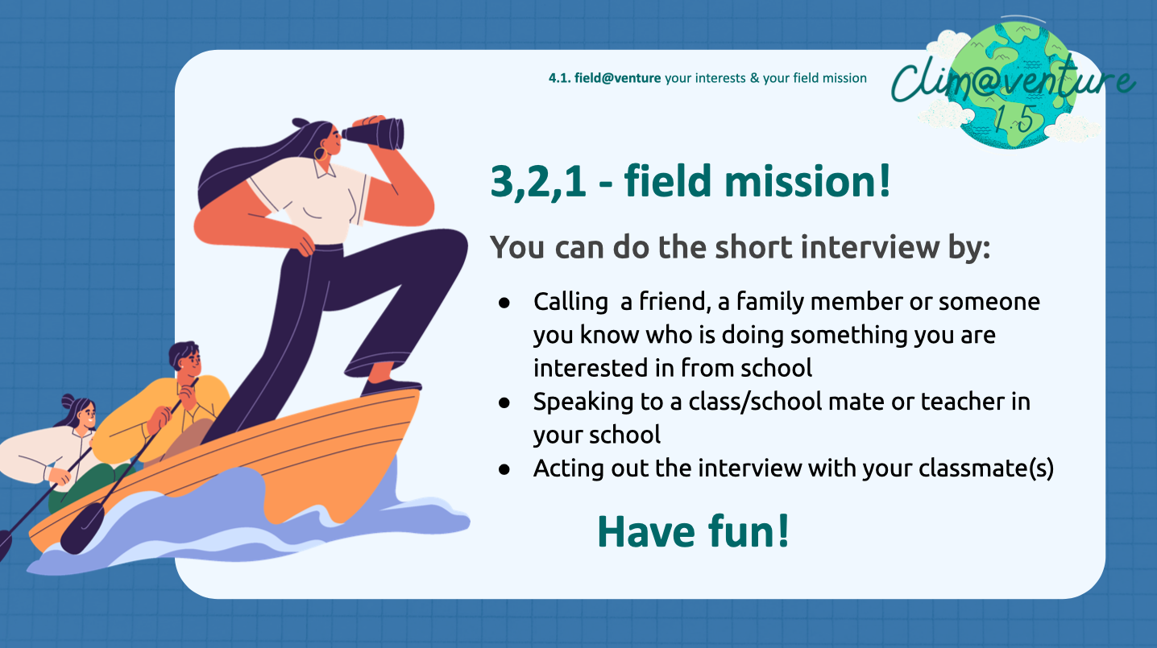 | 30’ | Remind your students that this is the fast track, so you do not have so much time.  This is why instead of going out into the fields for the interviews, your students can do the following:  - Calling a friend, a family member or someone you know who is doing something you are interested in (maybe from the contact mindmap from the previous exercise)  - Speaking to a class/school mate or teacher in your school  - If there is no one to be found, they can be acting out the interview with a classmate
12.  Optional | 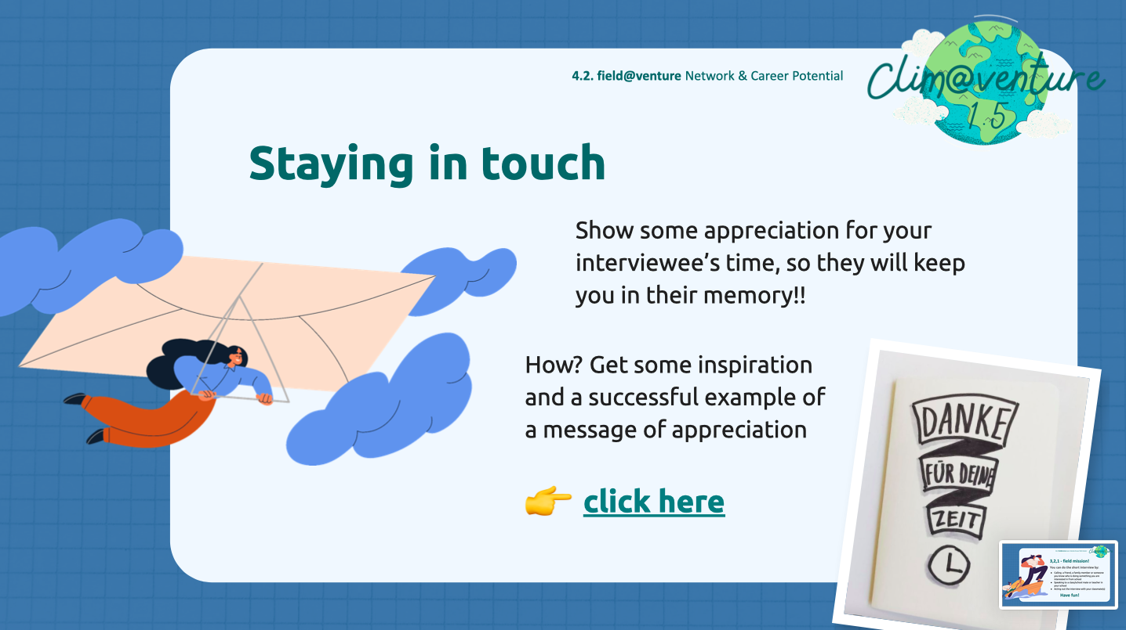 | 5’ | Tell you students that this is optional. This is a cool way to show some appreciation for their interviewee’s time, and a wonderful method to be remembered.  Writing a thank you card, writing a text or whatever they feel doing can make a difference and can keep the door open for future internship/work opportunities.
13. | 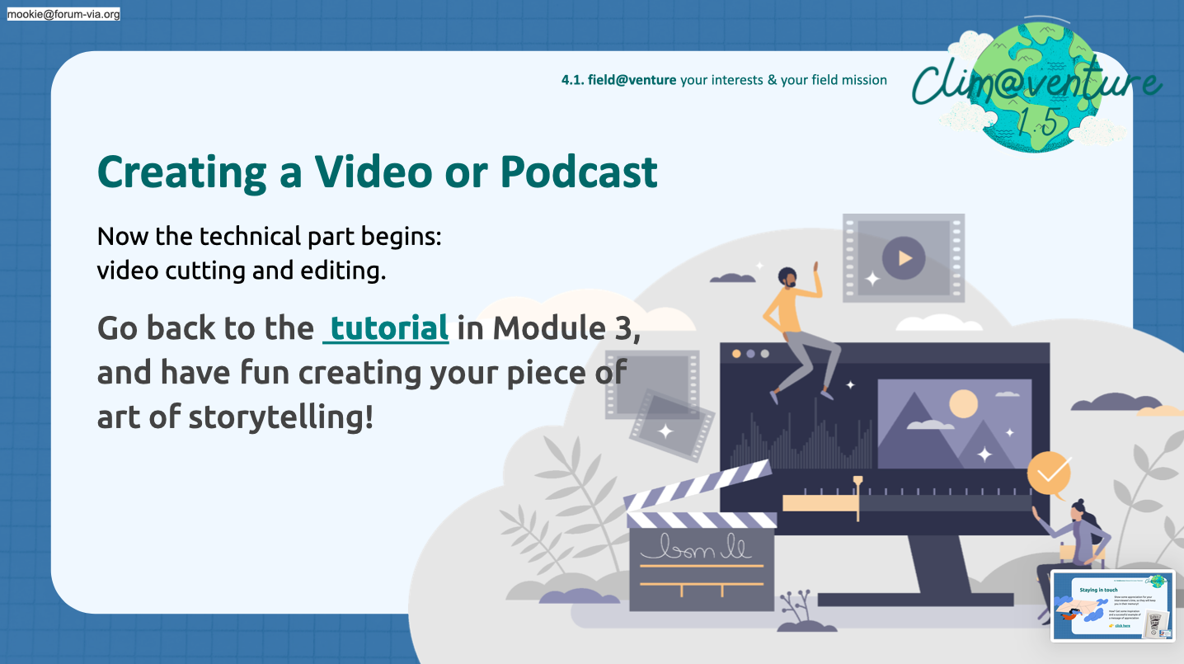 | 50’ | Now, it is time to create a SHORT and SIMPLE video or a podcast out of their (audio or visual) recordings. They can let their creativity go wild!  4. How to do a good video or podcast tecnically TUTORIAL - Clim@venture VIDEOBOX.mp4here is the link to the video of Module 3, if it is needed to be reviewed.
14. | 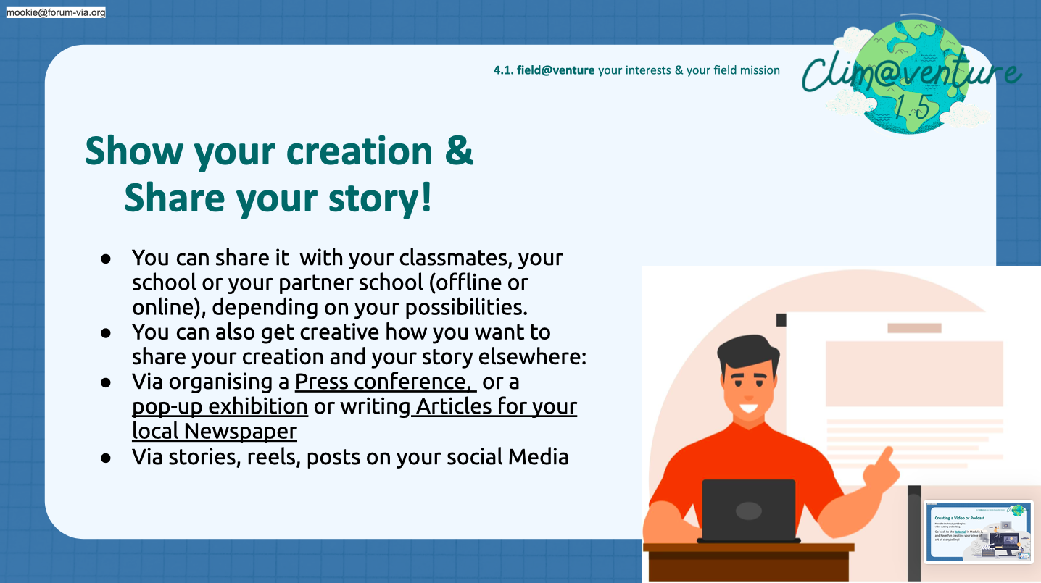 | 50’ | After creating a simple video or podcast, it is time to share it. Depending on your time, context and possibilities, you can do it within your class, with your school, or with your partner school (offline or online).  Your students can also get creative how they want to share their creation and their story elsewhere:  Via organising a Press conference, or a pop-up exhibition or writing Articles for your local Newspaper (see the links when pressing on the underlined text), via stories, reels, posts on their social Media.  Have fun!
15. | 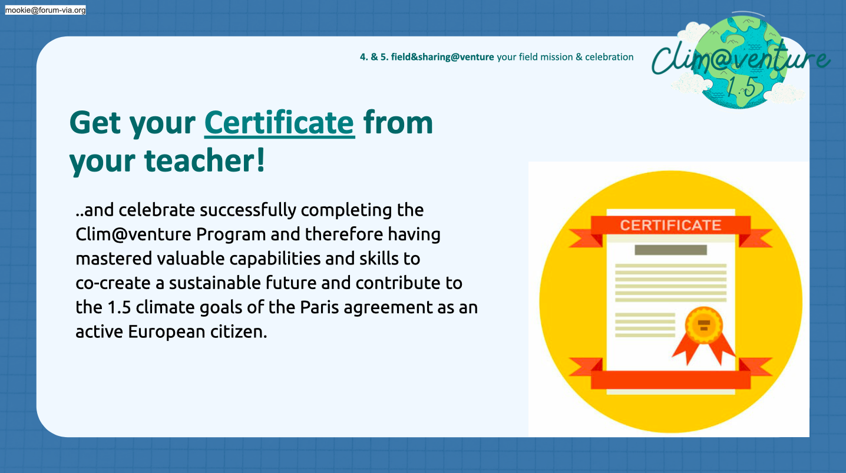 | 5’ | At the end of the journey, it is time to celebrate your students for being brave, creative and finished with the Clim@venture.  You can print these certificates and fill in their namesCertificate_Climatventure.pdf.

Feedback

